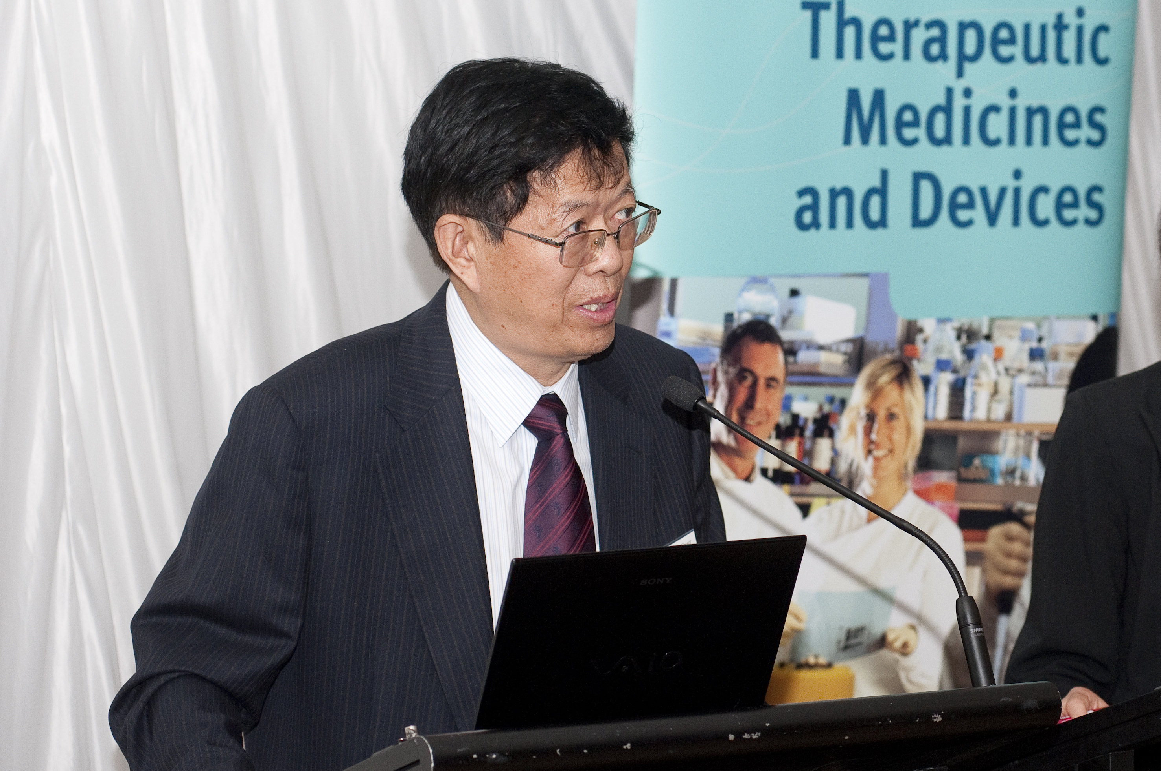
RESUME – Tingfei Xi Email: xitingfei@pku.edu.cn
PERSONAL DATA
Professor
Director of Center for Biomedical Materials and Tissue Engineering
Academy for Advanced Interdisciplinary Studies
& Director of Biomedical Engineering Center，Shenzhen Institute
Peking University
Fellow, Biomaterials Science & Engineering (FBSE)
EDUCATION
1972-1975 Graduated in Westnorth University ( Polymer Chemistry )
1976-1979 Teacher in Xian Petroleum College
1980-1982 Master degree of Medicine in Peking University
PROFESSIONAL EXPERIENCE
1983-2008.6 Prof., Director of Center of Medical Devices, National Institute for the Control of Pharmaceutical and Biological Products
1991-1993: Visiting researcher in National Institute of Health Science, Tokyo, Japan;
1995.1-6: Visiting researcher in Therapeutic Goods Administration, CDHHCS, Australia.)
2008.7- up to date Prof., Director of Center, Shenzhen Institute, Peking University
MEMBERSHIPS
International College of Fellows-Biomaterials Science and Engineering
Vice-President of Chinese Biomaterials Society
Vice-president of Chinese Biomedical Engineering Society
Chair of the Cardiovascular Intervention and Device Engineering Research Center, Ministry of Education
HONORS AND AWARDS
            - The second class prize for Advancement of Science and Technology of Zhejiang (2007)
            - The second class prize for Advancement of Science and Technology of Beijing (2004)
            - The third class prize for Advancement of Science and Technology of Beijing (1998)
            - The third class prize for Advancement of Science and Technology of Sichuan (1998)
            - The third class prize for Advancement of Medical Science and Technology of Ministry of Public Health (1988,1990, and 1994)
PUBLIC SERVICE
Experts of drafting scheme for the key “Biomedical Materials and Tissue Repairing” project of the National 13th Five-year Program
Special Expert of Biomedical Engineering, National Development and Reform Commission
Assessment Expert of Medical Devices, CFDA
Experts with Outstanding Contributions of Ministry of Health
Experts of Central Organization Department
Receiving the Special Government Allowance from the State Council

PUBLICATIONS & PATENTS
About 250 papers were published in International or Chinese Journals, related to biodegradation of biomaterials, evaluation on biomaterials and artificial organs, materials of planting perspectives, condoms, artificial heart valve nano-biomaterials, et al; 18 books or chapters in books were published in Chinese or English; 8 patents have been authorized.
Top most cited Chinese researcher according to Elsevier (Biomedical Engineering, 2015, 2016 and 2017).

